**Load Balancer**

Load balancer created in all the 3 availability zones.

The load balancer has http(80) and https(443) ports enabled to add more security.

Inorder to do that a certificate was created using Amazon Certificate Manager and a CNAME record was created in the hosted zone in route 53.

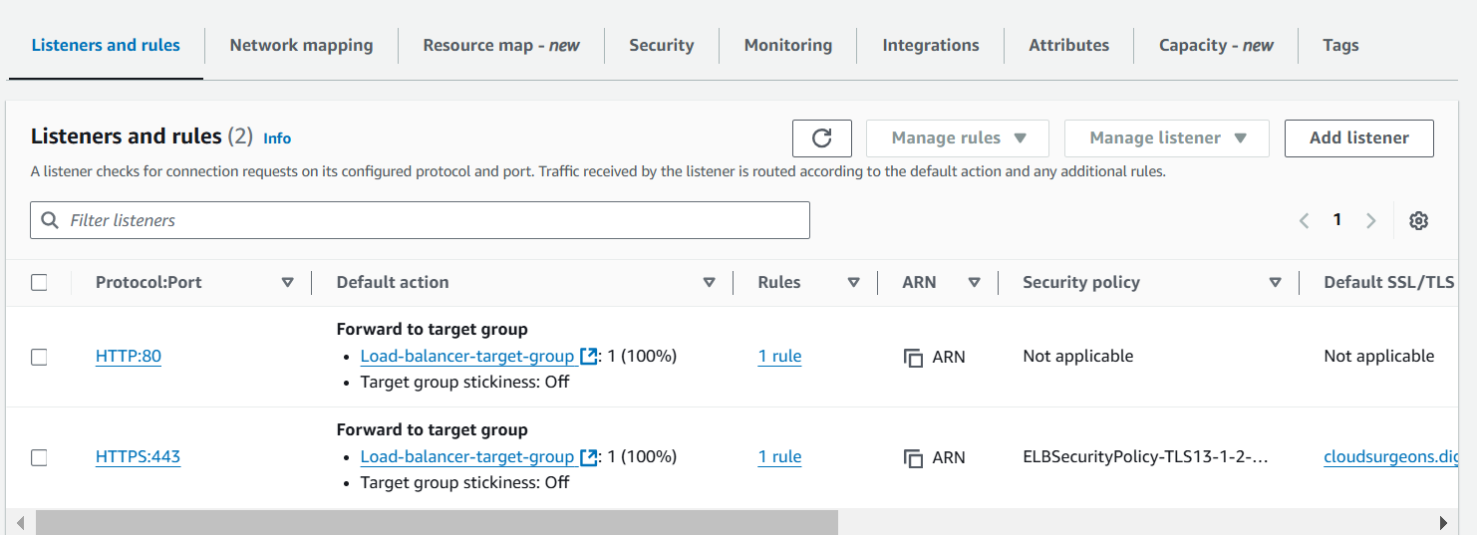

Now our website is accessible via https

